October is National Ergonomics Month!
by Alex Proaps

In 2003, the Human Factors and Ergonomics Society (HFES) designated October of every year to be National Ergonomics Month (NEM). The purpose of NEM is to focus on promoting human factors/ergonomics to corporate executives, students, and the general public by providing information and services to the community.

What is Ergonomics?

Ergonomics derives from two Greek words: Έργον, meaning "work", and Νόμος, meaning "natural laws.” Therefore, ergonomics is the science of work and a person’s relationship to that work. Ergonomics is also a science that focuses on the ways in which products fit the user; specifically, how products can be designed to decrease user fatigue, stress, injury, and discomfort, and to improve safety and efficiency. Ergonomists contribute to the design and evaluation of tasks, jobs, products, environments and systems in order to make them compatible with the needs, abilities and limitations of people.

Human Factors is a scientific discipline concerned with understanding the interactions among humans and the elements of a system. Human Factors scientists apply their knowledge of human’s physical and cognitive abilities and limitations to optimize human well-being and overall system performance. Part of a human’s well-being includes safety, so a major area of interest for Human Factors scientists and Ergonomists is to ensure people are safe.

We’d like to share some tips with you to help increase your child’s safety this Halloween without decreasing the fun!

Old Dominion University Human Factors and Ergonomics Society student chapter

Find us on Facebook (ODU Human Factors)!

References: Consumer Reports, US Consumer Product Safety Commission, Parent and Child Magazine, Ergoweb, Center for Disease Control

Pumpkin carving
by Alex Proaps

Pumpkin carving can be a very dangerous activity for children. According to the journal Pediatrics, injuries to the hand and fingers are the most common accidents on Halloween. One third of those accidents are cuts. Halloween accidents happen most often to kids ages 10 to 14, so it’s important that adults do the actual pumpkin carving. Put younger children in charge of drawing the face with a washable marker or scooping out the seeds with their hands. Even better for children, you could have them paint the pumpkin’s face and avoid cutting the pumpkin altogether.

Tips for safe carving
- Use a well lit area.
- Purchase a pumpkin carving kit because it will include a blade that makes it easier to cut a pumpkin’s tough skin.
- Use a short, strong blade if you do not use a kit – the longer the blade, the more likely you are to injure yourself.
- Make sure your hands are dry to reduce slippage.
- Cut in short strokes.
- Move your hand away from your body.
- Take your time.
- Put away sharp edges immediately.

Fire safety
If you do decide to make a Jack-O-Lantern this Halloween, remember that fire can pose a danger. Here are some fire safety tips:
- Clean out the inside of pumpkin so no pulp or strings are loose – they can catch on fire.
- Allow the pumpkin to dry out for a few hours and cut away any hanging pulp so it does not ignite.
- Do not use lit candles in artificial pumpkins, which are flammable.
- Use battery powered lights or glow sticks to remove the fire hazard.
- Do not place pumpkins filled with lighted candles outside where a child’s costume may catch fire. Some children and pets may also be afraid of the fire.

Costumes

Swords, knives, and similar costume accessories should be short, soft, and flexible.
Avoid trick-or-treating alone. Walk in groups or with a trusted adult.
Fasten reflective tape to costumes and bags to help drivers see you.
Examine all treats for choking hazards and tampering before eating them. Limit the amount of treats you eat.
Hold a flashlight while trick-or-treating to help you see and others see you. Always WALK and don't run from house to house.
Always test make-up in a small area first. Remove it before bedtime to prevent possible skin and eye irritation.
Look both ways before crossing the street. Use established crosswalks wherever possible.
Lower your risk for serious eye injury by not wearing decorative contact lenses.
Only walk on sidewalks whenever possible, or on the far edge of the road facing traffic to stay safe.
Wear well-fitting masks, costumes, and shoes to avoid blocked vision, trips, and falls.
Eat only factory-wrapped treats. Avoid eating homemade treats made by strangers.
Enter homes only if you're with a trusted adult. Only visit well-lit houses. Don't stop at dark houses. Never accept rides from strangers.
Never walk near lit candles or luminaries. Be sure to wear flame-resistant costumes.
Budnick, of ErgoWeb states: “From the physical ergonomics perspective, we should design our costumes to minimize exposure to such risk factors as force, posture, repetition, contact pressure, and vibration […] ”costumes shouldn't weigh too much and accessories and tools […] should be lightweight designs with handle designs that minimize grip forces and awkward wrist and arm postures.”

The US Consumer Product Safety Commission has some helpful tips for costume safety based on human factors and ergonomics research.
- Make sure all costumes carry the label Flame Resistant. These items may still catch on fire, but the fire can be extinguished more quickly.
- Avoid costumes that might impede movement in any way, causing tripping hazards.
- Costumes should be light and bright colored material. If you purchase costumes with dark material, attach reflective tape that will glow in a car’s headlights.
- Give every child a flashlight.
- Apply natural, non toxic makeup instead of using masks which restrict breathing and reduce a child’s vision.
The Center for Disease Control and Prevention outline the following tips to ensure everyone has a safe and fun Halloween:
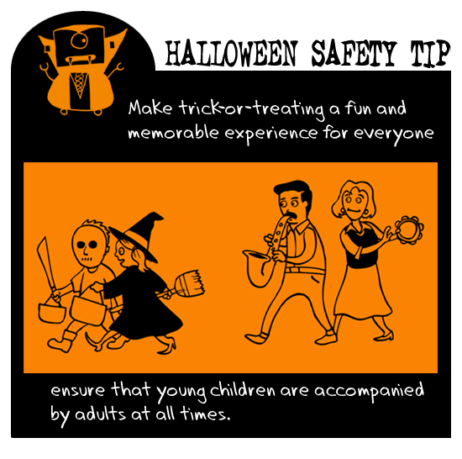
via onepagewonder.com

